Course Code: CSA1557

Course Name: Cloud Computing and Big Data Analytics

saliya sameer patankar

192221145

Demonstrate virtualization by Installing Type-2 Hypervisor in your device, create and configure VM image with a Host Operating system (Either Windows/Linux).

Step 1:We need to install VM workstation in our laptop.

Step 2:we need to create one license then only we can access the software.

Step 3:Go to file and choose create new folder.

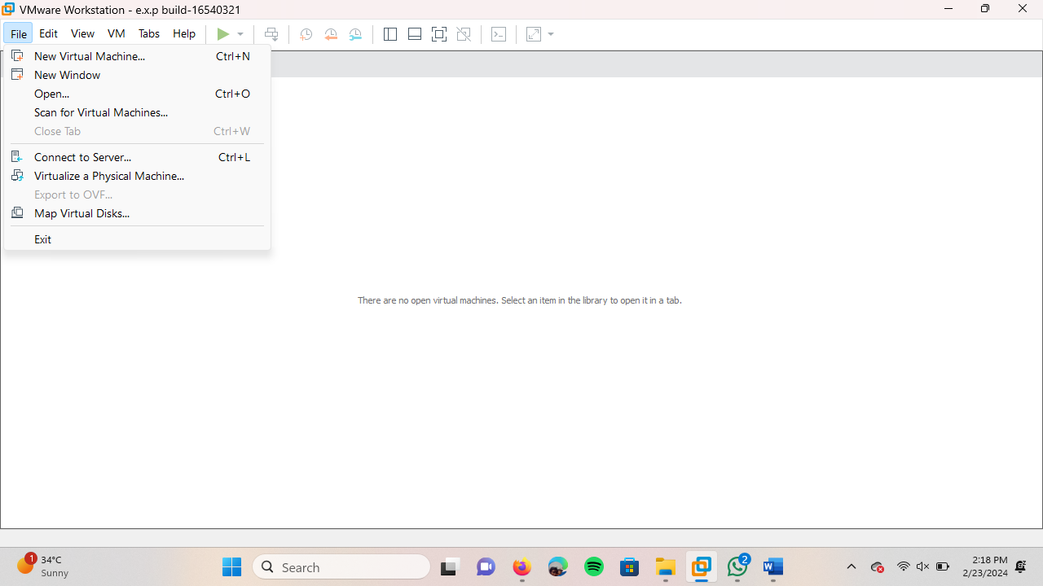

step 5: It will create one new folder of VM and give next option .

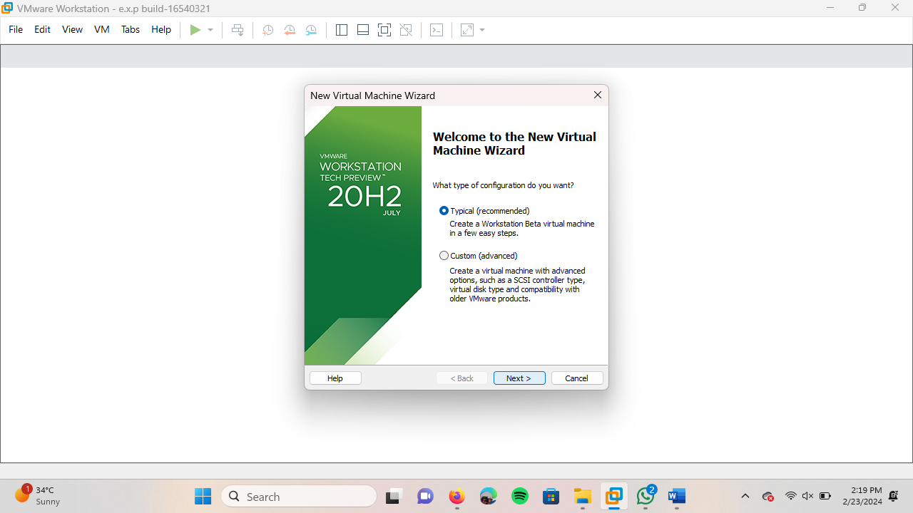

Step 6:Browse a ubutan folder and give next

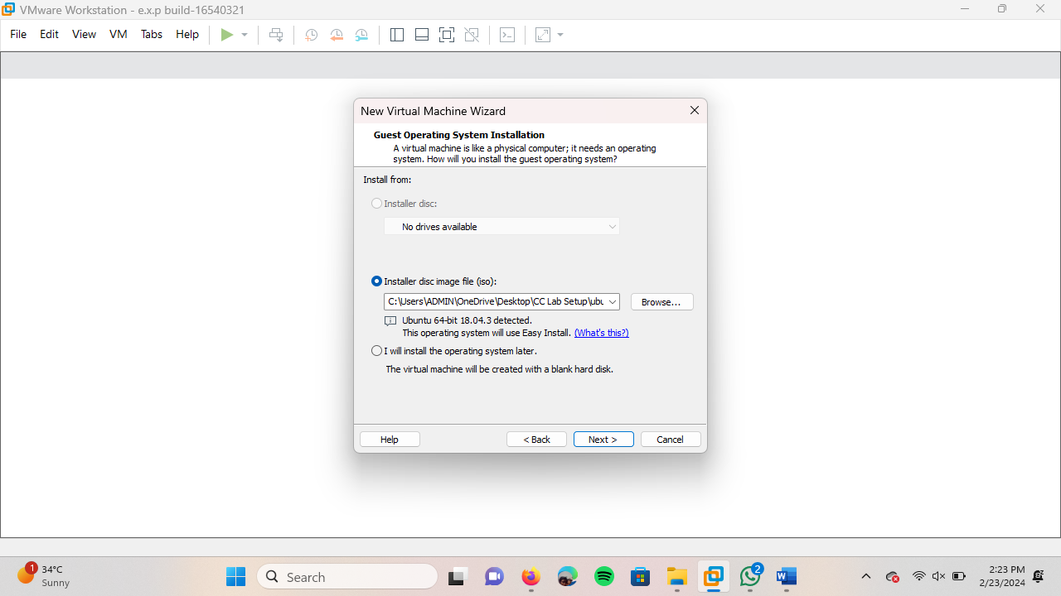

Step 7:Fill the name,Password and username upon you and give next.

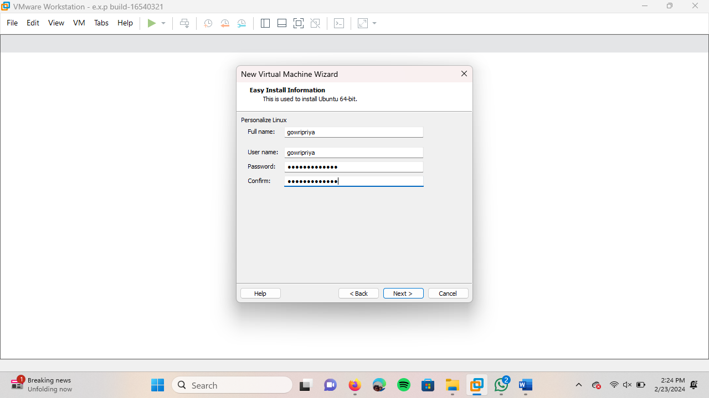

Step 8:create a virtual machine name and give next.

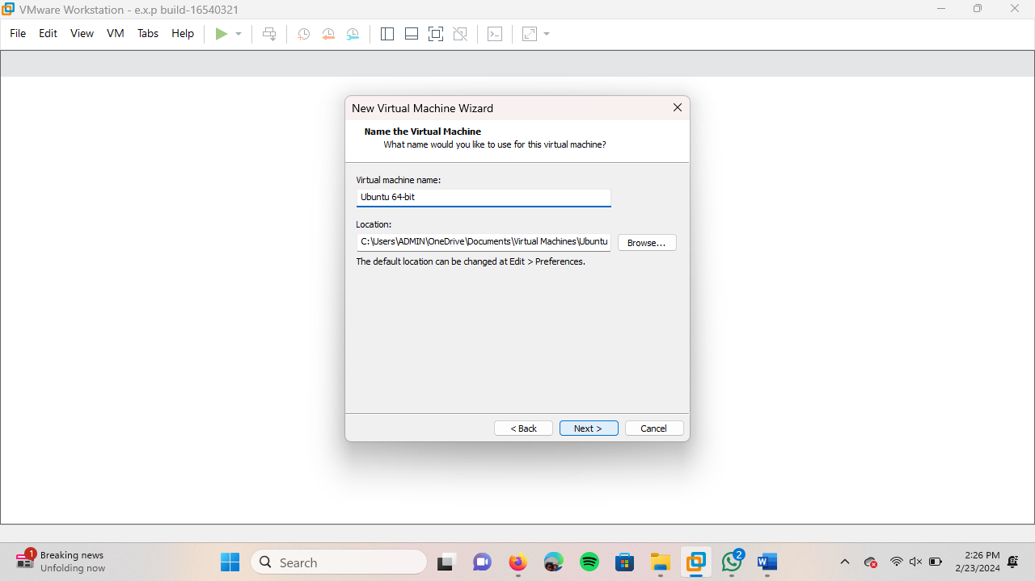

Step 9:Create a space for VM to run depends upon the device RAM and select store virtual disk as single file & choose next.

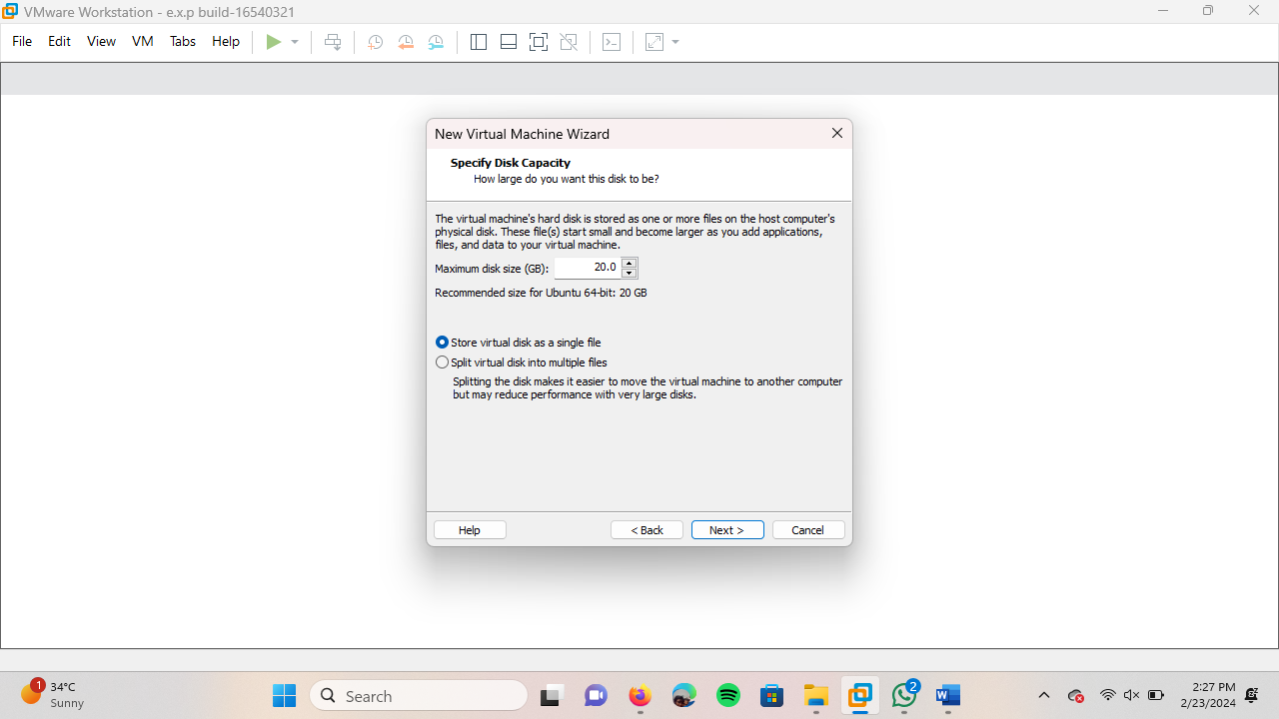

Step 10:Finish the step by giving the finish option.

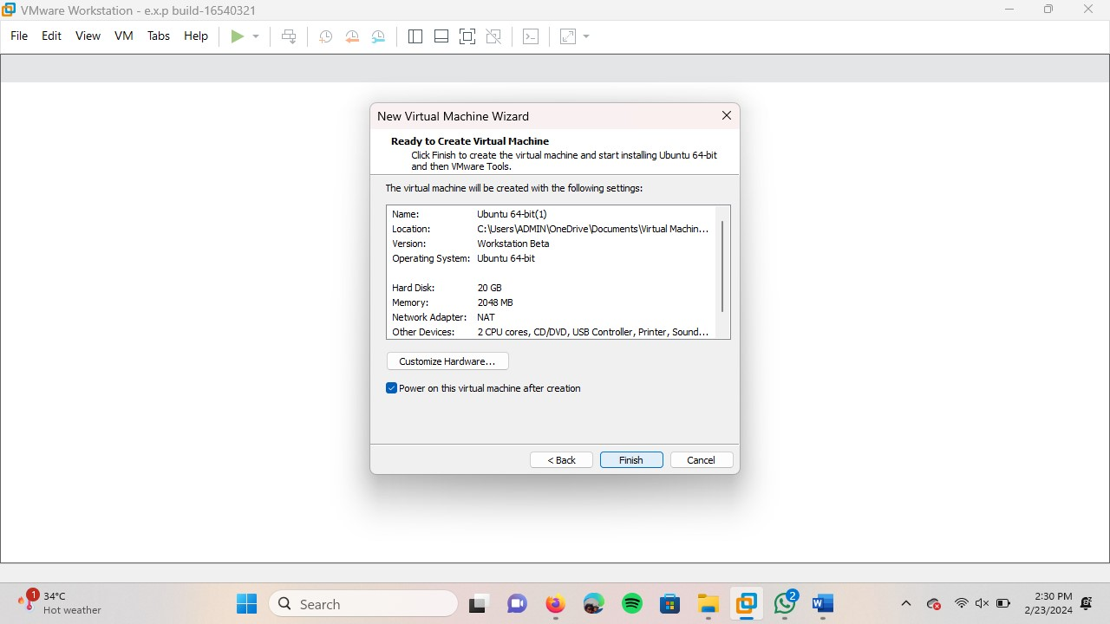

Step 10:Then it will take time to Run the VM.

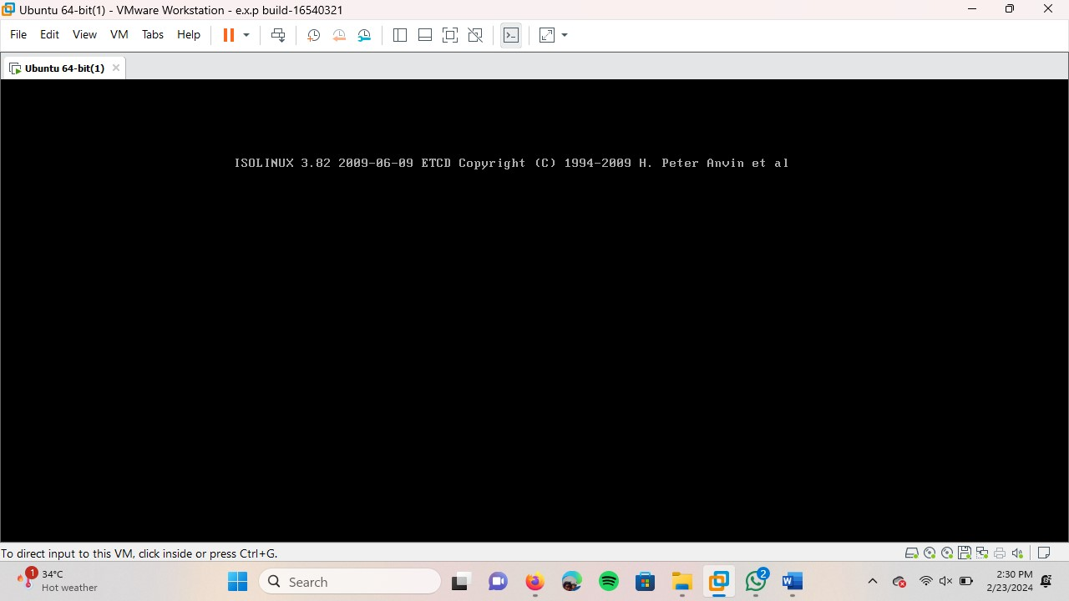

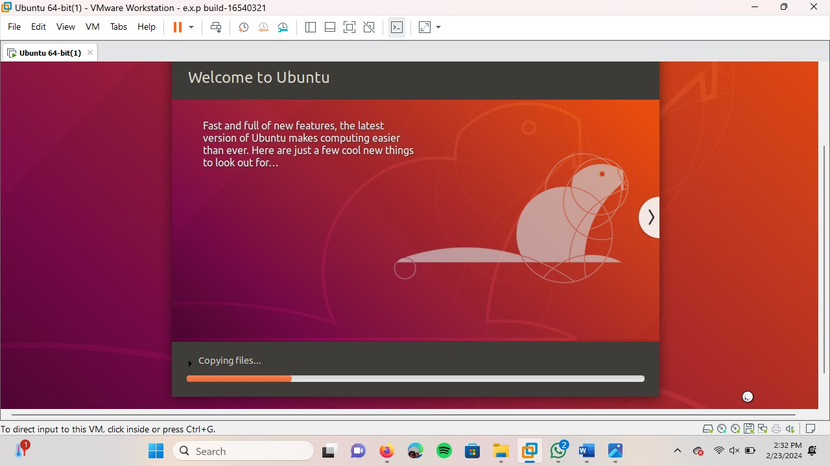

Step 11:When the step is completely done then we need to enter the password to access the VM.

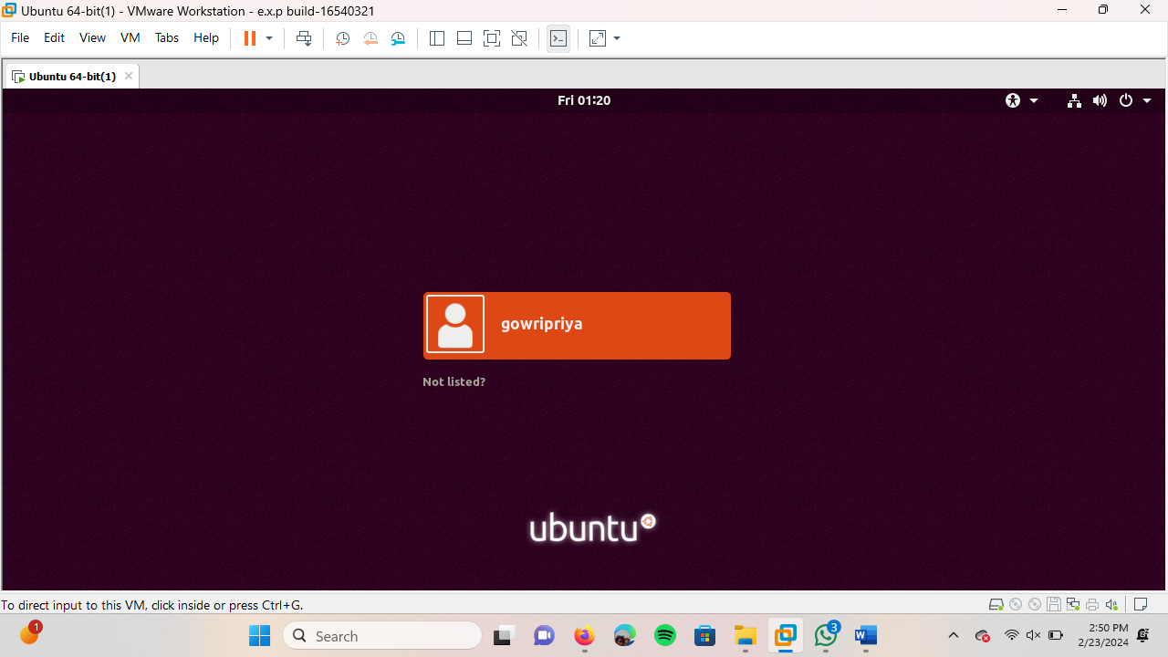

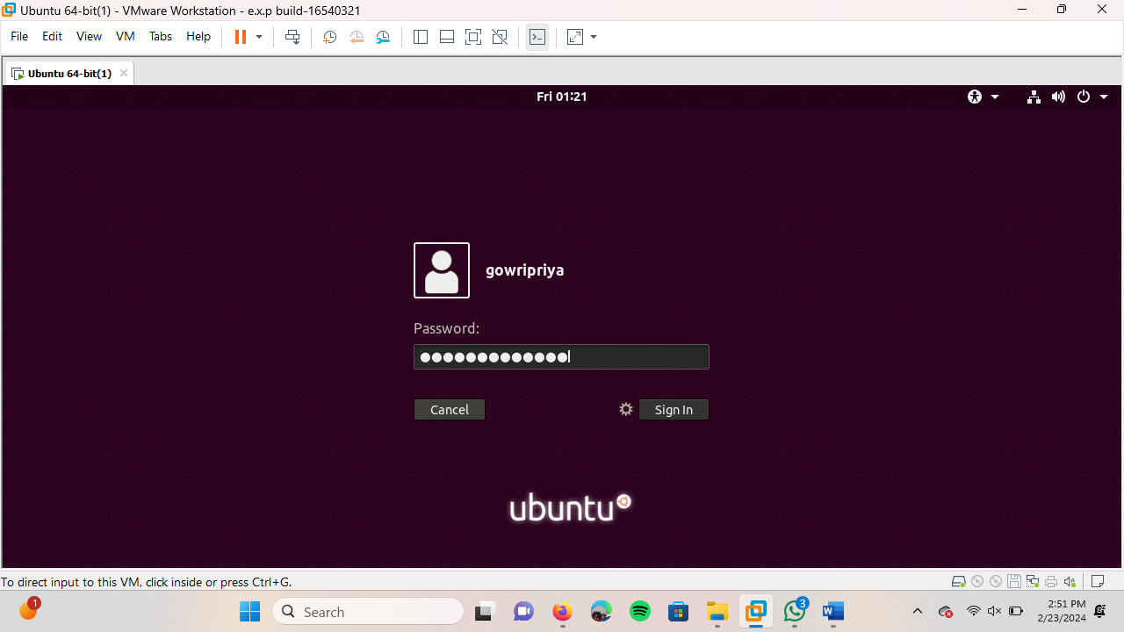

Result:

